40.30: According to Eq.40.26, the energy released during the transition between two adjacent levels is twice the ground state energy
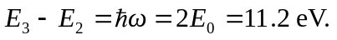
For a photon of energy 
